eZ Flow

Configuration Guide
version 1.0



Table of Contents
1.Introduction 4
1.1.Typographical conventions 4
1.2.More resources 4
1.3.Training and certification 4
1.4.Contacting eZ 4
2.Installing eZ Flow 5
3.Configuring the block system in eZ Flow 5
3.1.Defining page layouts 5
3.1.1.Defining new layouts 5
3.1.2.Layout templates for zone definition 7
3.2.Defining block types 7
3.2.1.Creating manually controlled blocks 7
3.2.2.Template for manual blocks 8
3.2.3.The result 9
3.2.4.Defining automatic blocks 9
3.2.5.The result of the dynamic block 11
3.2.6.Defining special blocks 12
3.2.7.The result of a special block 13
4.iPod Touch and iPhone templates 13
5.Video Streaming configuration 14
6.Glossary 15

Introduction
eZ Flow is an extension to eZ Publish that has extended functionality for handling the flow of content publication over time, specifically the rotation and placement of content on frontpages. Typical usage is a newspaper frontpage or managing a TV station’s portal. eZ Flow is ideal in situations where content changes quickly and there are many changes per day. eZ Flow is design to enable editors to plan the “flow” of content on these pages.

Target audience
This document explains how to configure eZ Flow and create custom page layouts and block types, and thus is appropriate for system administrators with a moderate degree of technical understanding and experience with eZ Publish. For information on using eZ Flow, refer to the usage guide.

Conventions
- Code samples, functions, variable names, and on are printed in monospace font.
- Filenames and paths are printed in monospace italic font.
- Commands are printed in monospace bold font.
- Elements of graphical user interfaces (such as buttons and field labels) are printed in bold font.
- Component names (such as an application) are capitalized, for example “Administration Interface”.
- In sample URLs, replace “example.com” with the domain name of your site.
- The screenshots in this document might have been modified to fit the page or to illustrate a point, and therefore might not exactly match the display on your site.

More resources
For assistance with eZ Publish, refer to the following resources:
- eZ Publish documentation: eZ Find is an extension to eZ Publish. Where appropriate, there are links in this document to the online versions of the eZ Publish documentation, located at http://www.ez.no/doc.
- eZ Publish forums: The forums on the eZ Systems website are a valuable community-driven resource, where eZ Publish users provide assistance and support to each other. Accessing the forums is free. The forums are located at http://ez.no/community/forum.
- Support from eZ Partners: eZ's global network of partners provides professional assistance for all eZ products. To find a partner, contact sales@ez.no.
- Other eZ solutions: For information about other solutions provided by eZ Systems, refer to http://ez.no/products/solutions.
- Training and certification: eZ Systems and eZ Partners offer training courses and certifications for eZ Publish. Contact sales@ez.no or visit http://ez.no/services/training for more information.

Contacting eZ
For non-technical questions regarding eZ Publish or eZ Systems, please contact us:
- http://ez.no/company/contact
- info@ez.no

Copyright and trademarks
Copyright © 2007 eZ Systems AS. Permission is granted to copy, distribute and/or modify this document under the terms of the GNU Free Documentation License, Version 1.2 or any later version published by the Free Software Foundation; with no Invariant Sections, no Front-Cover Texts, and no Back-Cover Texts. A copy of the license is included in the section entitled "GNU Free Documentation License".
Other product and company names mentioned in this manual may be the trademarks of their respective owners. We use trademark names in an editorial fashion to the benefit of the trademark holder; therefore, these names are not marked with trademark symbols. All terms known to be trademarks have been appropriately capitalized. We cannot attest to the accuracy of this usage, and usage of a term in this book should not be regarded as affecting the validity of any trademark or servicemark.

Installing eZ Flow
The installation process of eZ Flow is exactly the same as for eZ Publish Now. During the installation you get to choose between eZ Publish Now and eZ Flow. Other than selecting the eZ Flow package there is nothing special here.
The download will be the normal eZ Publish download. The eZ Flow extension will be downloaded during the installation from the Internet.
TODO: maybe just refer to the eZ Publish Now documentation for installation? Also eZ Flow will only be available in as an extension to eZ Publish Premium and is not meant in to be offered “out of the box” - since all potential media customers does need some kind of customization.

Configuring the block system in eZ Flow
When setting up the block system in eZ Flow you have two main things you configure. You can set up any number of different page layouts and you can define a number of custom block types.
By default the eZ Flow setup comes with a Frontpage class which uses the portal block system datatype. You can also create your custom classes that uses the block system. To do this you simply create a new class and add one attribute which is of the Page datatype.
TODO: what should we call it? I like layout system. Portal block system is also good (it can do what portal systems does basically) Maybe we should also rename the datatype from Page?

Defining page layouts
By default eZ Flow has three layouts, as shown in the screenshot below. The layouts that are available for the editor user is defined with a configurable plugin system. Where do users change layouts?
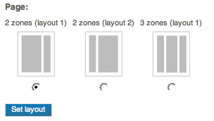

Defining new layouts
A “layout” is a combination of zones that are placed on a page. The placement of the zones is defined in a template that is specified as part of the layout configuration. You can define as many layouts as you need. To define a new layout, edit the zone.ini file (located by default in the directory extension/ezflow/settings/zone.ini.append.php). Add the layout name to the AllowedTypes array.
Once you have defined the layout type, define the following settings:

Setting Name | Description | Valid values
ZoneTypeName | The name of the layout. | String
Zones[] | An array defining the available zones and their identifier. | String
ZoneName[index] | The visible name of the indexed zone. Use the zone name as the index value. | String
ZoneThumbnail | The filename of the thumbnail image to use. The thumbnail show illustrate the arrangement of the zones. The thumbnails are by default located in the directory extension/ezflow/design/standard/images/ezpage/thumbnails.  When you have your own design repository you should place the thumbnails in the folder design/<your_design>/images/ezpage/thumbnails. | Filename
Template | The file containing the template that should be used for the layout. The layout templates are by default located in the directory  extension/ezflow/design/standard/templates/zone.  If you have a custom design the directory will be design/<your_design>/templates/zone | Filename

This example shows a configuration for a layout called “2ZonesLayout1”:

[General]
AllowedTypes[]=2ZonesLayout1

[2ZonesLayout1]
ZoneTypeName=2 zones (layout 1)

Zones[]=left
Zones[]=right

ZoneName[left]=Left zone
ZoneName[right]=Right zone

ZoneThumbnail=2zones_layout1.gif

Template=2zoneslayout1.tpl

Layout templates for zone definition
The template used by a layout must display the contents of the layout’s zones. You can place the zones anywhere in the template. The variable that is made available in the template is called $zones. This variable is an array containing different $zone objects. Each $zone variable contains both a $zone.name and $zone.blocks.

A simple example of a layout template is shown below.

{foreach $zones as $zone}

<h1>Zone: {$zone.name}</h1>

{foreach $zone.blocks as $block}
{block_view_gui block=$block}
{/foreach}

{/foreach}

Defining block types
What is a block? A block can either be manually controlled (for example a list of three news stories) or automatically generated (such as a tagcloud).
The configuration file for managing blocks is called block.ini. The default configuration file is located in the eZ Flow extension (extension/ezflow/settings). You should make an appropriate override, either globally or for a specific siteaccess. (For information on overrides, see XXX)

Creating manually controlled blocks
To create a manually controlled block, enter information about the block in a new section in the block.ini file. The definition of a manual block consists of the following elements.

Setting Name | Description | Valid values
Name | The name of the block. | String
NumberOfValidItems | The number of items that the block can display. | Integer
NumberOfArchivedItems | The number of archived items to display. | Integer
ManualAddingOfItems | Enable manually adding items. | enabled or disabled
TemplateList[] | A list of templates the editor can choose from. | Template filename.

Below is a configuration example for a three-column news block.
[Manual3Items]
Name=3 Column News
NumberOfValidItems=3
NumberOfArchivedItems=5
ManualAddingOfItems=enabled
TemplateList[]=3_items.tpl

Once this is defined the new block is available in the dropdown list of block types in the admin, as shown in the following screenshot.

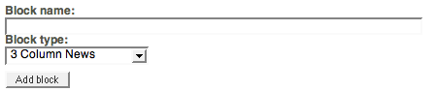

Template for manual blocks
The templates for manual blocks are located in the block directory in the template repository. For example, the location of the template defined above would be templates/block/3_items.tpl.
The block template gets a number of template variables set. The available template variables are:
- block_name: a text string that is the title entered by the editor
- items: an array of content nodes that is displayed in the block

The template code for displaying three items in a column using div-based layout might look like the example below. Here each item is accessed directly via the $items[index] variable.

<h2 class="grey_background">{$block_name}</h2>

<div class="columns-three">
<div class="col-1-2">
<div class="col-1">
<div class="col-content">

{node_view_gui view=line content_node=$items[0]}

</div>
</div>
<div class="col-2">
<div class="col-content">

{node_view_gui view=line content_node=$items[1]}

</div>
</div>
</div>
<div class="col-3">
<div class="col-content">

{node_view_gui view=line content_node=$items[2]}

</div>
</div>
</div>

The result
After the block is defined editors can add items to the block (as explained in the eZ Flow user guide). For example, a block with three items might look like the screenshot below in the administration interface:
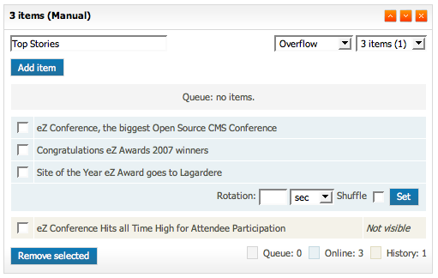
The final result on the website might look like the screenshot below:
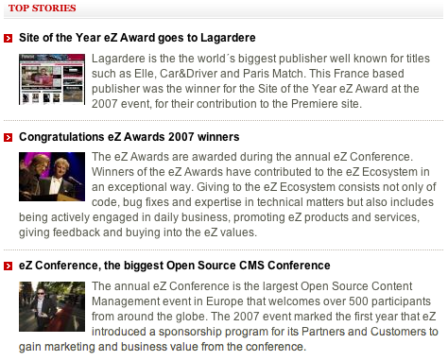
This block is manually, meaning that the editor chooses which items to display in the list. There is no automatic fetching of items.

Defining dynamic blocks
While the content in manual blocks is specified by an editor, dynamic blocks are a combination of automatic fetching rules (implemented via a plugin system) and editorially controlled parameters.
The dynamic block settings have more options than the manual block. The following settings need to be configured for each dynamic block.

Setting Name | Description | Valid values
Name | The descriptive name of the block. | Text string
NumberOfValidItems | The number of items that can be displayed in the list. | Integer
NumberOfArchivedItems | The number of items to have in the visible archive. | Integer
ManualAddingOfItems | Disable the ability to manually add items in the block. | Enabled or disabled
FetchClass | The class to use for the dynamic fetching rules (PHP class). | String
FetchFixedParameters[] | A list of fixed parameters to send to the fetching class. | String value that sets the key and value: FetchFixedParameters[class]=article
FetchParameters[] | Definition list of the required fetch parameters.
FetchParametersSelectionType[] | Definition of which selection type to use for the specific fetch parameter. The parameters are added by the editor. This can either be single or multiple selection of content items. | Single or multiple
FetchParametersIsRequired[] | Definition of which fetch parameters are required. If none are defined all are optional. | True or false
TemplateList[] | A list of the templates that can be used for this block. | Template filename

The following example shows a configured dynamic block:
[Dynamic3Items]
Name=3 items (dynamic)
NumberOfValidItems=3
NumberOfArchivedItems=5
ManualAddingOfItems=disabled
FetchClass=ezmLatestObjects
FetchFixedParameters[]
FetchFixedParameters[Class]=article
FetchParameters[]
FetchParameters[Source]=nodeID

# Single / Multiple
FetchParametersSelectionType[Source]=single

FetchParametersIsRequired[]
# True / False
FetchParametersIsRequired[Source]=true

TemplateList[]=3d_items.tpl
TemplateList[]=3d_list.tpl

The template code for displaying the dynamic block using div-based layout might look like the example below:

<h2 class="grey_background">{$block_name}</h2>

<div class="columns-three">
<div class="col-1-2">
<div class="col-1">
<div class="col-content">

{node_view_gui view=line content_node=$items[0]}

</div>
</div>
<div class="col-2">
<div class="col-content">

{node_view_gui view=line content_node=$items[1]}

</div>
</div>
</div>
<div class="col-3">
<div class="col-content">

{node_view_gui view=line content_node=$items[2]}

</div>
</div>
</div>

The result of the dynamic block
The following screenshot shows how an dynamic block appears to an editor working on the site. Notice here that you can choose the source and once the source(s) are chosen the name is displayed to the right of the button. (TODO: update screenshot to snow name, not ID)
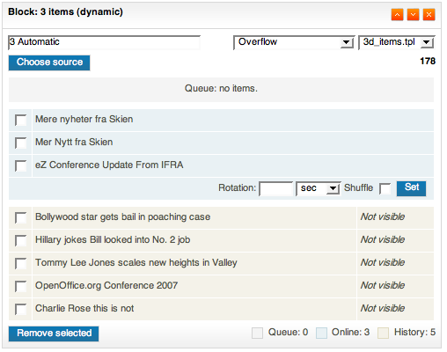
The result of the dynamic block described above is shown below. From the site visitor’s perspective, is looks the same as a manual block. The difference is that when something new is published in the the selected block source it is automatically displayed, and does not require an editor to make the content “live”.
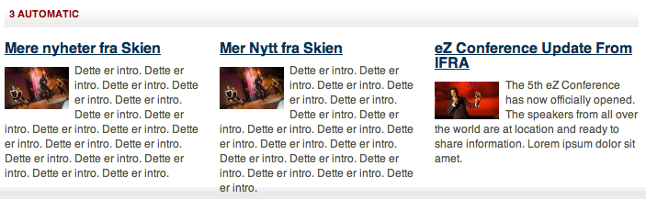

Defining special blocks
In addition to manual and dynamic blocks, eZ Flow also allows for custom blocks. Custom blocks do not have a pre-defined list of content. A custom block can be used to publish content entities like tag clouds or banner ads.
The following settings need to be configured for each custom block.
Setting Name | Description | Valid values
Name
ManualAddingOfItems | For special blocks disable the
CustomAttributes[]
UseBrowseMode[]
TemplateList[] | A list of the templates that can be used for this block. | Template filename.

An example of the settings for a special block that displays a tag cloud is shown below.

[TagCloud]
Name=Tag cloud
ManualAddingOfItems=disabled
CustomAttributes[]=subtree_node_id
UseBrowseMode[subtree_node_id]=true
TemplateList[]=tag_cloud.tpl

The template for a tagcloud is show below:

<div class="attribute-tag-cloud">
<h2 class="grey_background">{$block_name}</h2>
{eztagcloud( hash( 'parent_node_id', $block.custom_attributes.subtree_node_id ))}
</div>

The result of a special block
TODO: add screenshot for editor

A site visitor sees the tag cloud like this:
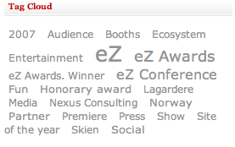

iPod Touch and iPhone template example
eZ Flow includes templates tuned for mobile display. These templates are examples that show how you can display content on various devices.
Displaying content on alternate devices is enabled via the eZ Publish siteaccess system, with a separate siteaccess for each type of device. (TODO: link to siteaccess docs on ez.no) Each siteaccess contains custom templates, specifically:
- Pagelayout
- Article full view
- Gallery full view
The documentation for the templates used in eZ Publish can be found at ez.no: http://ez.no/doc/ez_publish/technical_manual/3_10/templates
TODO: add screenshots from actual iPhone.
The Apple iPhone includes a full-featured webbrowser which means that it can display most website content (excluding elements such as Flash). It is normal to tune the content specifically for mobile devices. In the case of iPhones, you simply provide some templates which are tuned for the display size (320 pixels wide).
For information on how to tune your CSS and templates for iPhone, visit Apple’s development resources:
http://developer.apple.com/iphone/devcenter/designingcontent.html

Video Streaming configuration
The video streaming functionality included with eZ Flow enables recording and streaming live video and playback of recorded videos. You need to have a functioning Red5 installation in order to use this functionality.
eZ Flow integrates with the Red5 streaming server. For installation information on Red5 visit: http://osflash.org/red5.

Configuring the video recorder
You can create multiple video recorder interfaces in eZ Flow. Each needs to be connected with the streaming server (Red5) and a file server (Apache). The screenshot below shows the dialog for creating a new Video recorder object.
- Name: The name of the recorder.
- Streaming server: The URL of the rtmp location of Red5.
- File server: The server where you have configured Apache to list and serve the previously recorded videos.
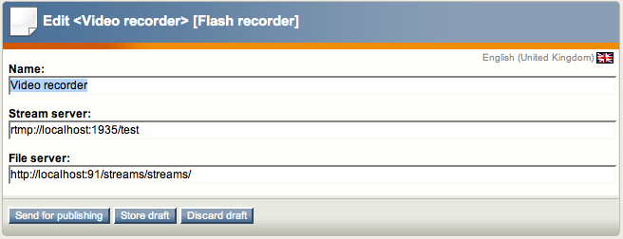

Configuring the file server
Red5 must be installed on a webserver where Apache is also installed. Apache can be used to list and serve the files that have already been recorded. This is an example of the Apache configuration:
# Red5 Streams sharing
<VirtualHost *:100>
<Directory /Applications/Red5/webapps/test/streams>
Options FollowSymLinks
AllowOverride None
</Directory>

DocumentRoot /Applications/Red5/webapps/test/streams
ServerName localhost
</VirtualHost>

The specified directory is the folder where Red5 places the recorded videos. This directory must also have the file flash_video_list.php. This is a PHP script which lists the files that have already been recorded and is used by eZ Flow to show the latest recorded videos.

Recording video
Once the player object has been created you can create video recordings. The screenshot below shows the video recorder’s initial dialog where you allow Flash to access your camera.
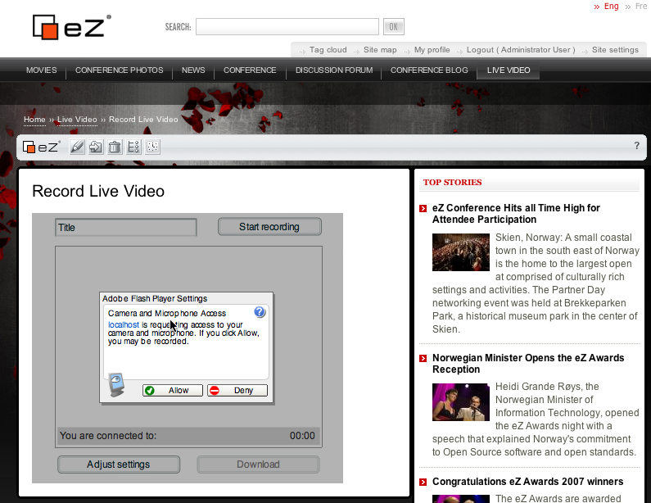

After Flash is connected to the camera, you have access to the video recorder as shown below. The title of the video can be entered before you start the recording. Once the recording has started the video is available as a live stream for site visitors. Once you stop the recording, the file is encoded as a Flash video and made available for download. Alternatively, the file can be edited in video editing software and later uploaded for display.
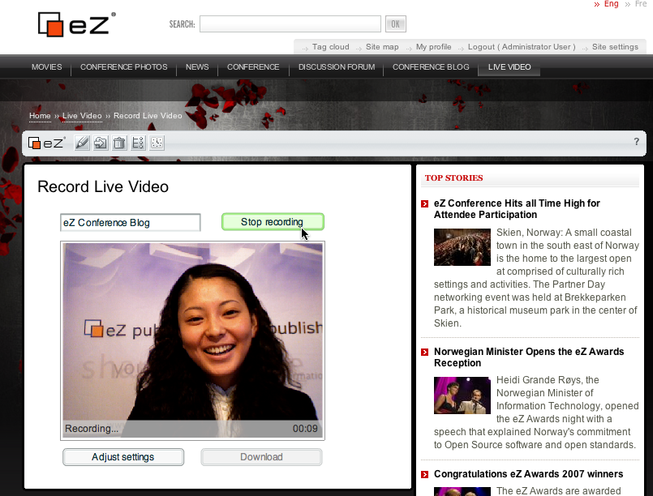
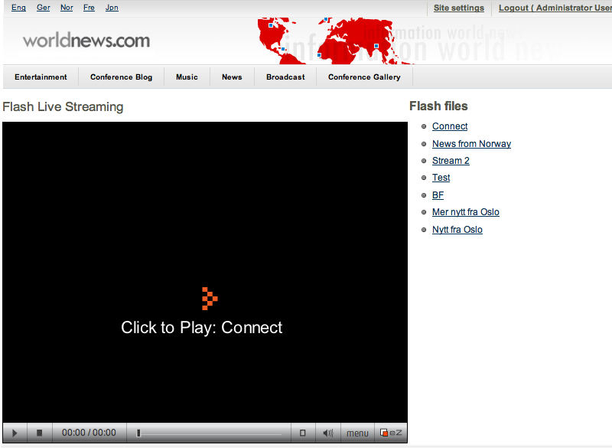
The screenshot below shows the list streaming interface and a list of the most recently added videos. If there is currently a live streaming session, it will also be automatically listed.

